**YAML introduction:**

* YAML is nothing but a file format where we can represent data

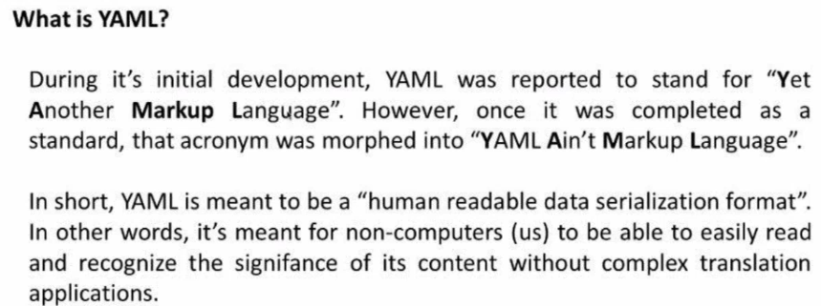

**XML vs JSON vs YAML:**

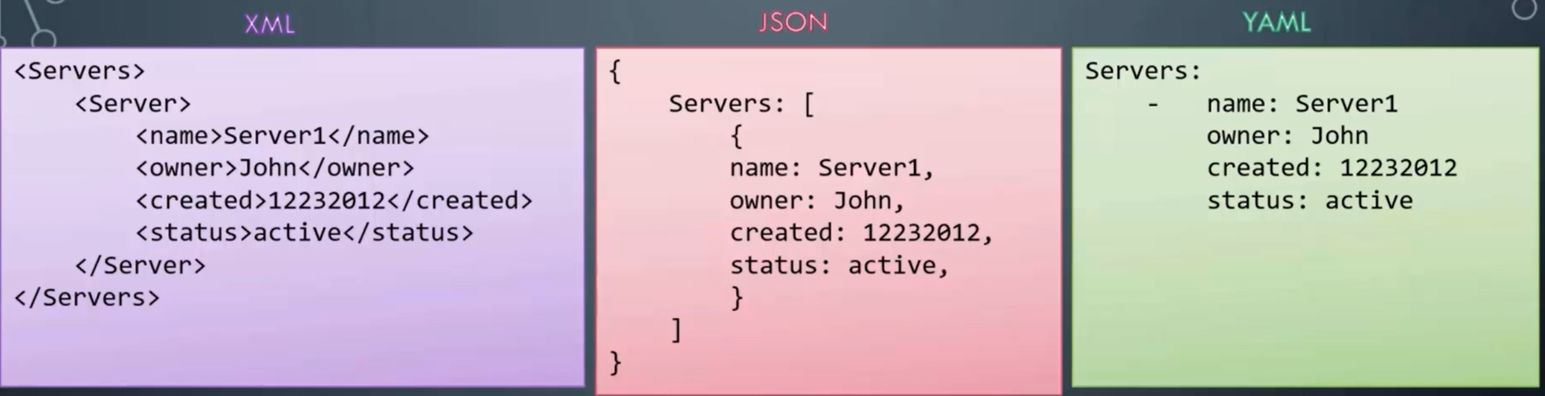

* Any yaml file starts with - - - . these dashes indicates the start of a new yaml

**Key value pair:**

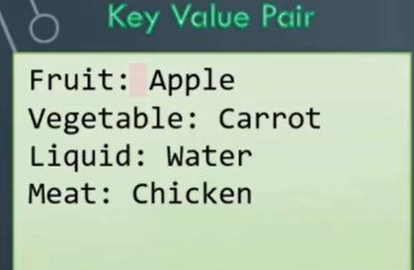

* We must give the space after **“:”** in key value pairs

**Array/Lists:**

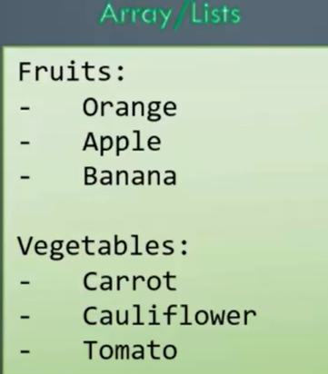

* Whenever we are telling about the multiple items, each item starts with single - as shown in image

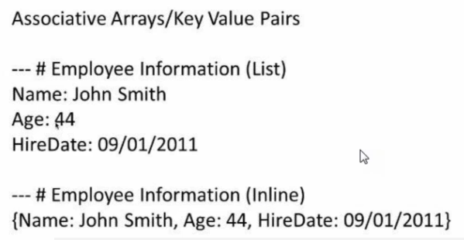

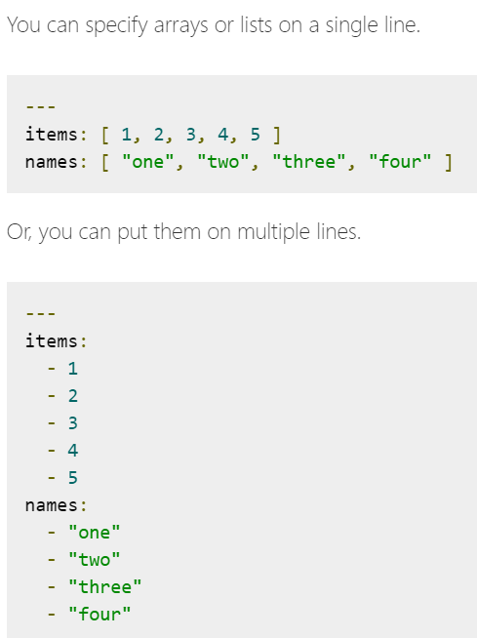

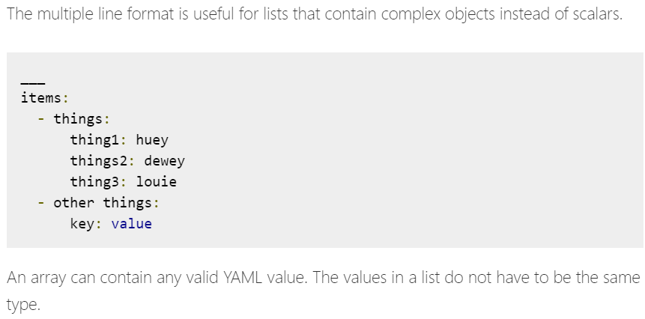

**Dictionary/Map:**

* Directories are set of key value pairs as below.

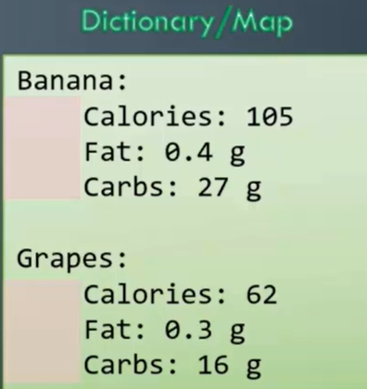

* Space must be giving same for all the properties in dictionary format.

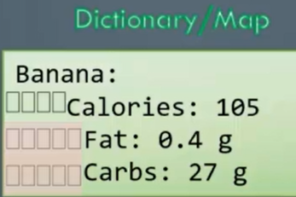

* If we give space as above, “fat” and “carbs” will fall under “calories” property

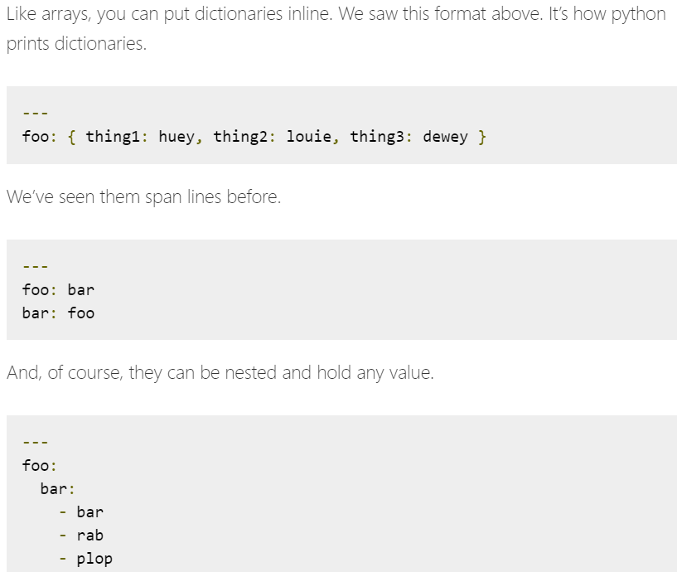

**Key value/Dictionary/Lists:**

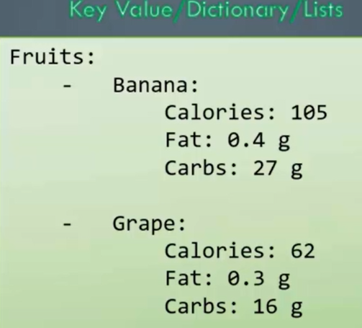

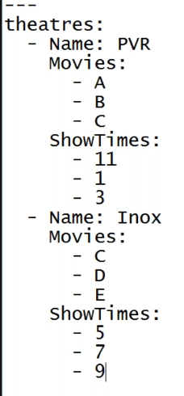

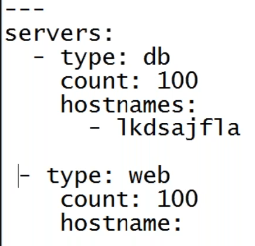

**Dictionary in dictionary:**

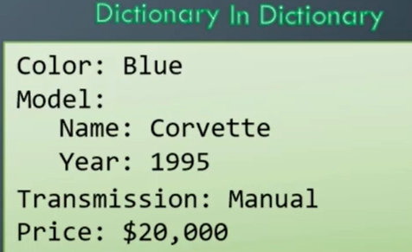

**List of dictionaries:**

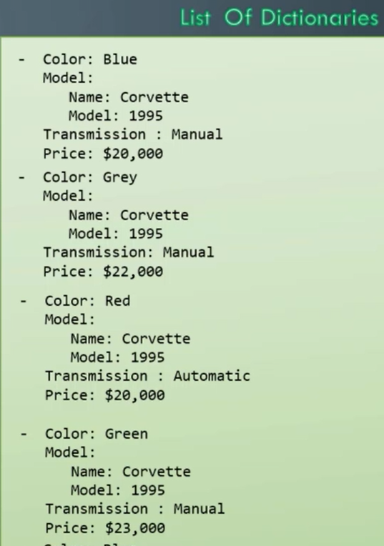

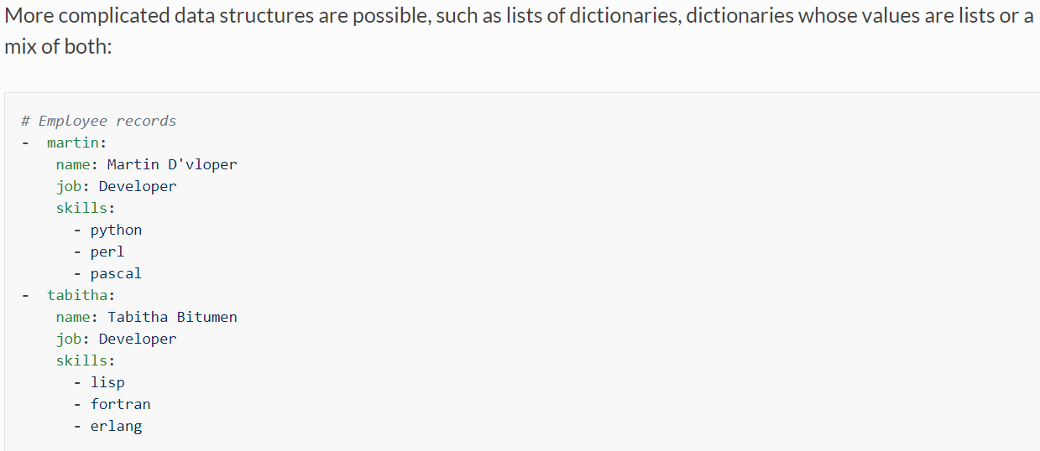

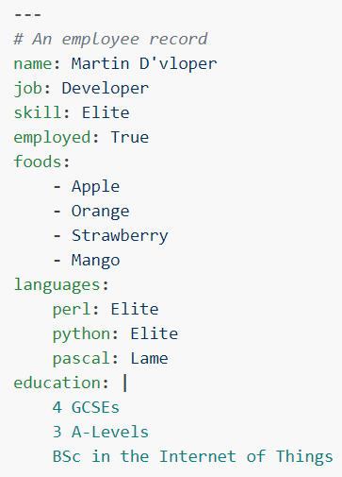

* As above, if all the keys are related to same employee, then no need to use “-“ option.
* If we have the details of multiple employees, then we need to add “-“ to the first key of each employee.

**Notes:**

Dictionary is unordered and list is ordered as below.

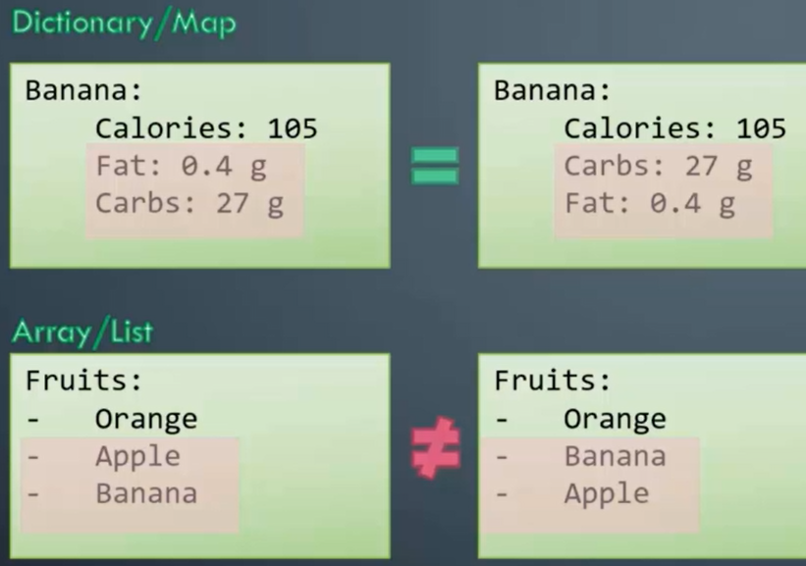

# can be used to comment out any line in yaml file

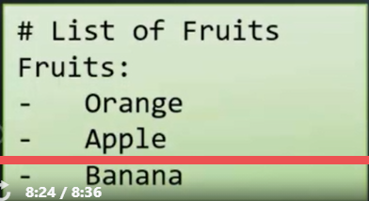

**Numeric types:**

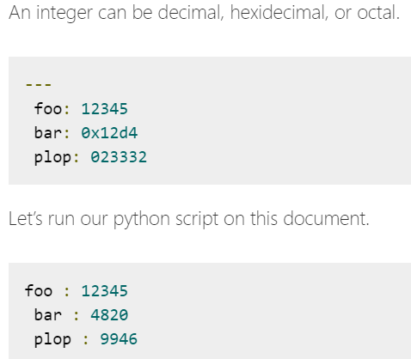

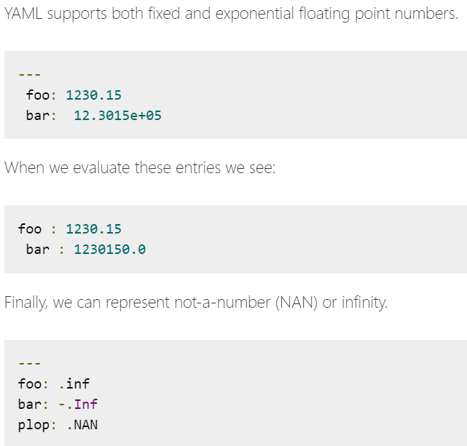

**Strings:**

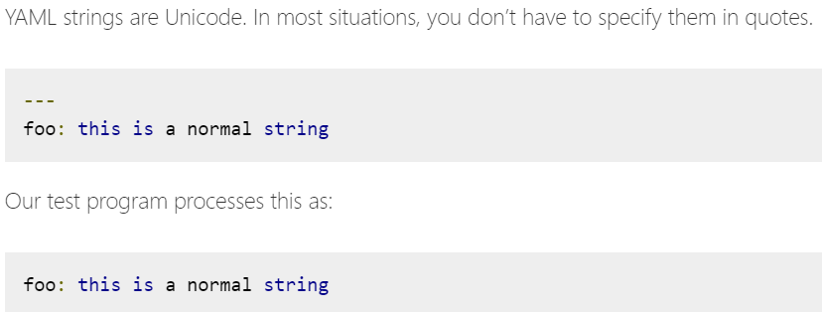

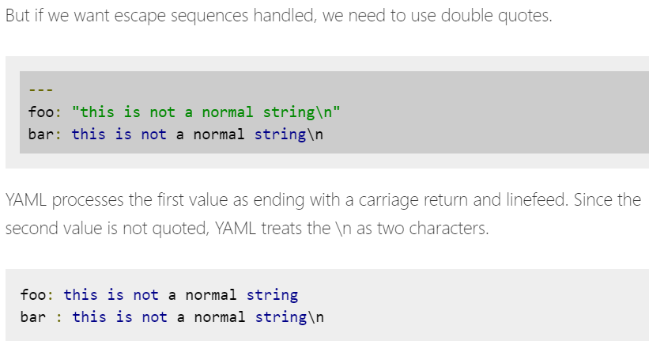

* We can also have multiple lines in string as below.

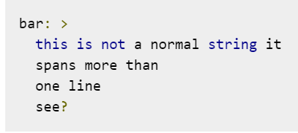

* But it will be taken as a single line



* We can user pipe (|) symbol to take the data as it is.

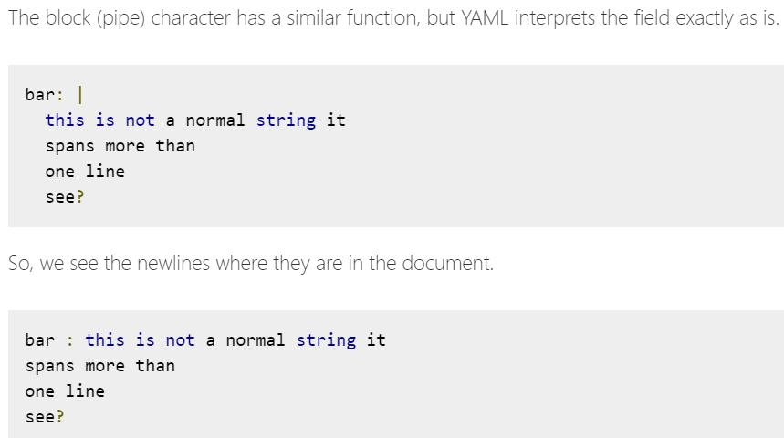

**Nulls:**

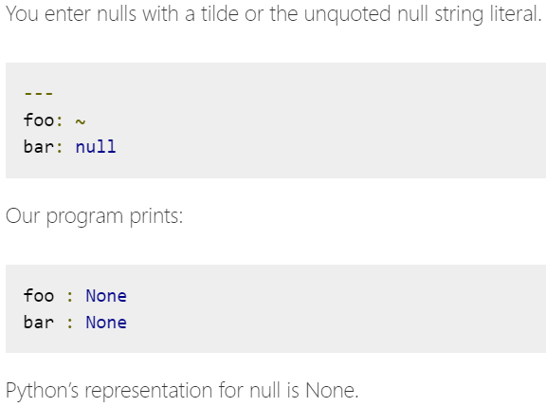

**Booleans:**

